Grace Jones

South Sudan has been a victim of internal conflict and civil war for almost a century. According to Human Rights Watch, more than 4 million people have fled their homes with half taking refuge in neighboring countries. Seven million people need humanitarian assistance and face food shortages.
Food security seems to be one of the most prominent issues within this crisis as approximately 9,000 people lose food access daily with a reported fifty percent of the population experiencing food crisis or famine-like conditions. Organizations such as the UN World Food Program (WFP), UN Children’s Fund (UNICEF), USAID’s Office of Food for Peace, and non-governmental organizations (CARE, Catholic Relief Services) have assisted in providing food programs and interventions across the country as well as food vouchers and products for food distribution. However, South Sudan continues to be a very dangerous place for aid workers due to the civil conflict and violence. Additionally, taxes on transport and weather difficulties make it difficult to transport supplies. The UN and WFP continue to work on ways to provide support to South Sudan. The FFP contributed approximately 376.2 million dollars in 2019 to South Sudan and approximates another 92.5-million-dollar contribution for the current year.
Displacement is also caused by the violent conflicts that have caused people to flee and seek protection from the UN and other countries. This past week the president and vice president agreed to form a unity government to end the ongoing civil war. Due to differences in ethnic groups the two leaders have feuded to a point of one of the largest refugee crises seen to date. While this is a hopeful step, previous agreements fell through in 2019 and the original peace agreement was made in 2018. While recent governmental changes provide some hope in improving the current state in South Sudan there is skepticism in how long the cease-fire might last as well as possible improvement and security outcomes. Either way, South Sudan is far from resolve and need for assistance remains high. Actions should be taken to further provide for the country and increase awareness as little attention is being dedicates to a conflict that has been ongoing, taking many lives with it.
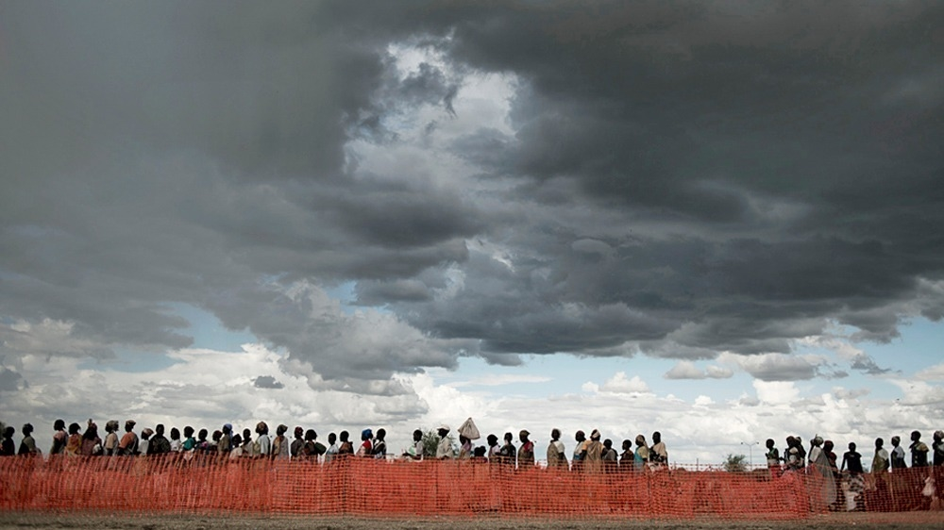
The above image shows a line to collect food rations at a UNMISS-compound in Malakal South Sudan illustrating the famine that is taking place in the country. Taken from: http://www.thenewhumanitarian.org/analysis/2014/06/19/war-rain-and-money-anatomy-south-sudan-s-food-crisis
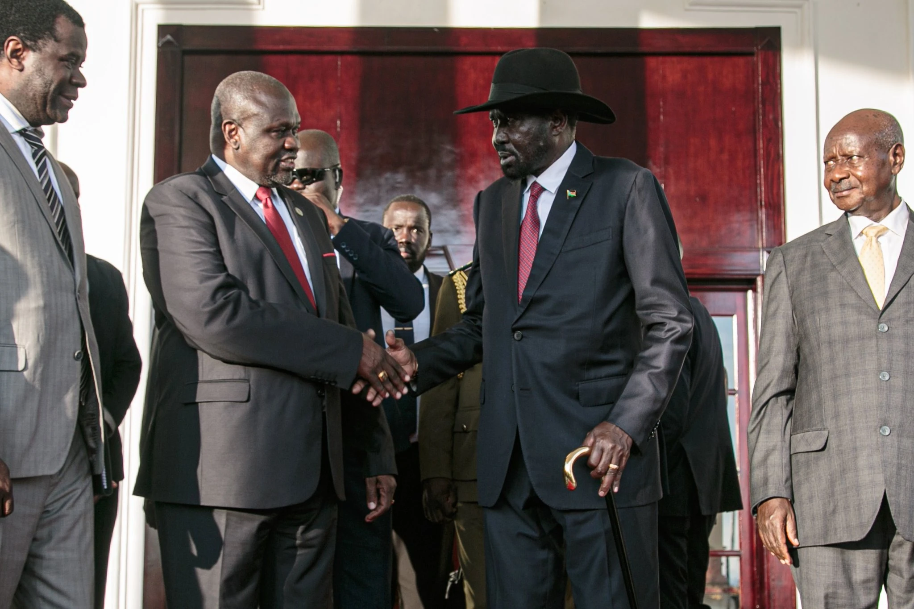
The above image shows Salva Kiir, President of South Sudan (right) shaking the hand of Vice President Riek Machar (left) during the establishment of a hopeful unity deal on February 22 of this year. Taken from: https://www.nytimes.com/2020/02/20/world/africa/south-sudan-peace-deal.html
Additional References:
https://www.care.org/emergencies/south-sudan-humanitarian-crisis
https://www.hrw.org/world-report/2019/country-chapters/south-sudan
https://www.crisisgroup.org/africa/horn-africa/south-sudan/major-step-toward-ending-south-sudans-civil-war
https://www.usaid.gov/south-sudan/food-assistance

